Ionic Foot Spa for Full-Body Detox - $ 35
- Detox your whole body (especially organs) using ion technology in the ionic foot spa. Ionic technology allows for the removal of toxins safely & painlessly through the pores in your feet.
- Simply sit with your feet in a tub of salt water attached to the ionic array. After your treatment, the remaining toxins are left behind in the water. [see chart]

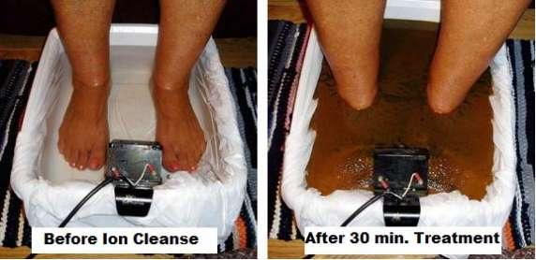
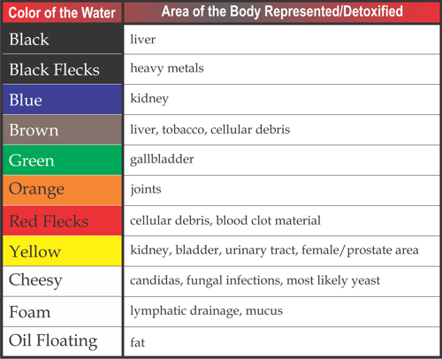

Ionic Foot Spa Questionnaire
Do not use if:
- I have a pacemaker, defibrillator, and/or other electrical implants.
- I am pregnant and/or lactating
- I am an organ transplant recipient
- I am currently taking blood thinners.
- I am a hemophiliac or an epileptic
- I currently have metal plates in my body
- I currently take medication for hypertension
- I currently have open wounds on my feet
- I am currently undergoing radiation or chemotherapy

I understand that if I have: titanium implants, diabetes, congestive heart failure, or any other medical condition I should consult my physician prior to using the ionic foot detox spa.

I understand that I should not wear any metal, operate a computer, or use a cell phone during the foot spa session.
If there is any apprehension or confusion, your physician should be consulted.

I have completed the checklist to help my therapist keep me safe and I guarantee all the above information to be true to the best of my knowledge. I understand that the information provided is not intended to be a substitute for professional medical advice, diagnosis, or treatment. I should never disregard professional medical advice or delay in seeking it. The information provided is based on norms and information provided by the manufacturer and testimonials. I understand that anyone associated with Massage, Health, & Wellness LLC is not a physician. Any recommendations made about my health and/or lifestyle should be discussed between me and my physician. I understand that there are always risks associated with any technology and/or treatment/bodywork and I do not hold Massage, Health, & Wellness liable.

Signature ________________________________________ Date ___________________

